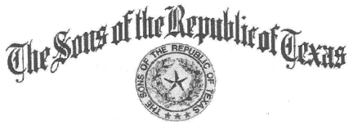
Chapter President Chapter Secretary

Steve Manis Clark Wright
Chapter Vice President Chapter Treasurer
Ronnie Schoolcraft Mike McCown

Sidney Sherman Chapter #2

Minutes of the meeting of the Sidney Sherman #2, Sons of the Republic of Texas

The Sidney Sherman Chapter #2, Sons of the Republic of Texas met at Ryan's Steakhouse in Texas City January 5 between 6 and 8 P.M.

All officers (Steve Manis, Ron Schoolcraft, Clark Wright and Mike McCown) attended this meeting. Tom Green opened the meeting with a prayer, and we recited pledges to the American and Texas flags.

Members attending were:
Billy Mayo
David Ware
Doug McBee
John Lucas
Matt Kane
Mike Mitchel l

SRT members:
Tom Green

Guests were:
Shailee Manis

Prospects were:
James Cantrell

Our program was presented by Jim Nonus who provided us with an excellent portrale of Jean Lafitte, explaining his interest n the Galveston area.

We closed the meeting with benediction from Tom Green.

Respectively submitted, Clark P. Wright

